



DMTA Study abroad

Table of Contents

**Document Requirements** 3

**Passport** 4

**Vaccination Record** 5

**Financial Documents** 6

**Certificate of Finance** 7

**Application Form** 8

**Travel/Health Insurance** 9

**F-1 VISA** 11

**J-1 VISA** 17

**U.S.A Jargon Buster** 22

**Travel Grant** 23

**Budgeting** 24

**Accommodation** 27

**Important Contacts** 28

**Cost Overview** 29

# **Document Requirements**

|  |  |  |  |  |  |  |  |  |  |
| --- | --- | --- | --- | --- | --- | --- | --- | --- | --- |
|  | Passport | Vaccination Record (Inc. meningitis) | Financial Documents | Certificate/ Statement of Finance/IS-50 | RBC Exchange Sheet | Application Form | Transcript (supplied by college) | Travel/ Health Insurance | Student Essay |
| SFA (Texas) | 🗸 | 🗸 | 🗸 | 🗸 | 🗸 | 🗸 | 🗸 | 🗸 | N/A |
| OCU (Oklahoma) | 🗸 | 🗸 | 🗸 | N/A | N/A | 🗸 | 🗸 | 🗸 | 🗸 |
| Centre College (Kentucky) | 🗸 | 🗸 | 🗸 | N/A | N/A | 🗸 | 🗸 | 🗸 | N/A |

1. If you feel a personal statement may help us in evaluating your application, you may include it with the other materials. A personal statement should tell us something about your background and your future aspirations, particularly in relation to your experience at Oklahoma City University.

Student Handbook: <https://issuu.com/okcu/docs/2016-17studenthandbook>

**Privacy Notice:** how your data is held is subject to the legislation in data protection abroad

# **Passport**

You can either make a copy yourself or Student Services can organise this. If you decide to make your own copy it needs to be a **clear** and in **colour** like the example given below;

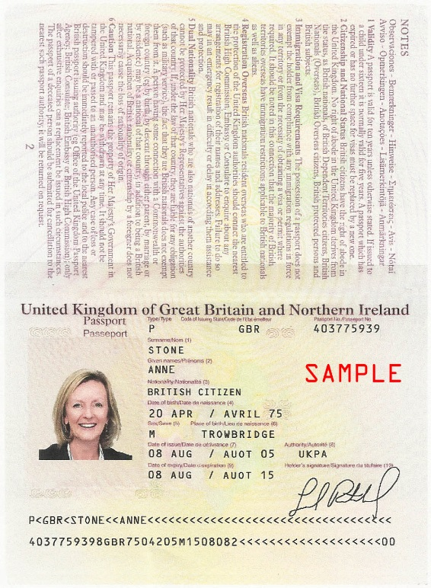

# **Vaccination Record**

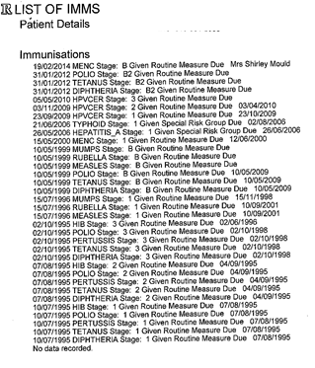

Your vaccination record should look along the lines of this;

|  |
| --- |
| **You need to make sure you are vaccinated against:** |
| Measles, Mumps & Rubella (MMR) |
| Pertussis,Tetanus & Diptheria – record must show the details of each strand and dates |
| Bacterial Meningitis (ACW & Y) – record needs to specify if strands Menactra and Menveo are covered |

**Extra:** All International Students must show proof of TB Skin test results from their home country completed within 30 days of arrival or pay Oklahoma City University to administer the test upon arrival. You will need to speak to you GP about obtaining this.

# **Financial Documents**

If you are getting Student Finance for your trip we need the letter that looks like this:

Your maintenance loan will need to be up to the value of £8,000 to cover the costs of living in

America. If your loan is less than this you will need someone such as a parent to support your

application, please see below.

**When you apply for SFE please apply as study abroad.**

**Or** an original bank statement from the applicants sponsor(s) verifying funding of approx. **$8,000 USD** alongside a letter from the bank holder to say these funds are available to you during your stay. The funds have to be in your account by the time you make your visa appointment but your confirmation letter needs to be ready before the forms are sent away (**April 1st**).

Make sure you apply for SFE as early as possible! SFE take at least 7-10 days to process applications not taking into account any hiccups that may occur. The student records team will be sending a spreadsheet off to Student Finance England (SFE) once you are confirmed to go to the U.S.A that lets them know you are a UK student but studying a semester abroad.

# **Certificate of Finance**

The form on the left is required if you are going to **SFA** and we need it electronically and in hard copy.

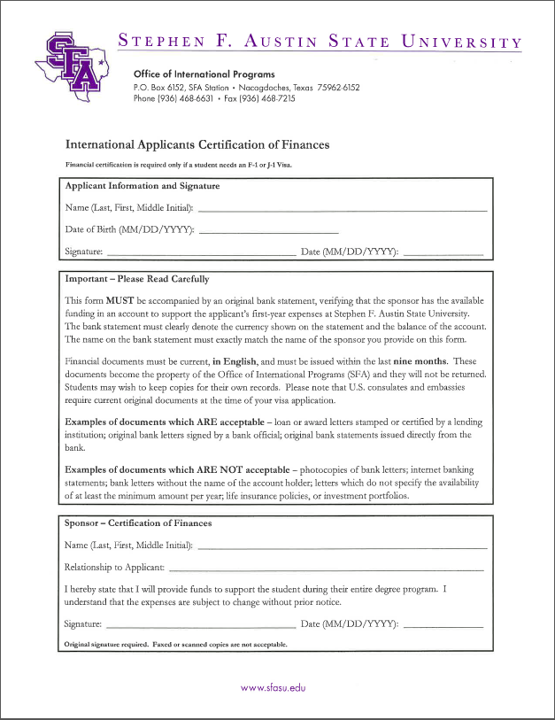

# **Application Form**

|  |  |
| --- | --- |
| **OCU** | Sent by OCU once you are confirmed. |
| **SFA** |  |
| **Centre** | Sent by Centre closer to the time of application |

**SFA NOTE:** Student to apply directly to SFA via this link; <https://www.applytexas.org/adappc/gen/c_start.WBX> and send passport and vaccination record to Tiffany Banks to forward alongside the forms above. Make sure you apply as an **‘undergraduate international transient student’.**

# **Travel/Health Insurance**

**Centre**

They offer their own medical insurance which is advised not to purchase while in the UK. Once they arrive in the USA, they will be covered under our plan. It is $106/month (approx.) and is added into their tuition/room and board payments. In the mean time you can have a look at their website, <http://www.lewermark.com/>

**Oklahoma City University**

The university has compulsory health insurance. The cost for 16/17 was $650 per semester and may change depending on government policies. You still need to get insurance from the day you fly until the day of your orientation.

If you have comprehensive insurance already you can apply for a waiver here; <https://studentcenter.uhcsr.com/school-page>

**SFA**

Our insurance will cost approximately $470 for the fall semester. Students can sign up for the insurance upon their arrival to campus. Alternatively, they can choose their own insurance, but it must conform to the guidelines set forth in the attached document.



**Please note:** Your own chosen insurance must comply with the above guidelines and cover you from arrival in the US to your last day of studies.

**COE Connections**

COE Connections is an travel insurance **option**. COE does not cover medical so that needs to be separately bought but this is a very good travel insurance option.

COE Connections International are a Long Stay travel insurance specialists in the United Kingdom and can be found at [www.coeconnections.co.uk](http://www.coeconnections.co.uk).

We offer a fully automated, IMMEDIATE online Quote and Buy system and our **STUDY ABROAD** premiums are highly competitive.

 Approximate costs;

**6 Months EUROPE.....................£93.00**

**12 Months EUROPE...................£185.00**

**6 Months WORLDWIDE.............£114.00**

**12 Months WORLDWIDE...........£211.00**

We can cover OVERSEAS students who have already resided in the United Kingdom and studied at a University here for (say) two years and are having their third year as study abroad, before returning back to the UK to complete their studies.

**Online Travel Cover**

Another insurance option; <http://www.onlinetravelcover.com/Default.aspx>. The standard long stay cover is approximately £117.99.

**Medical Insurance**

You can get travel insurance that covers medical, we recommend minimum up to $10m. To compare prices you can use; <https://www.moneysupermarket.com/travel-insurance/enquiry/results?qr=36804072>. COE Connections includes medical cover.

**Non- EU Travel/Medical Insurance**

<http://www.imgeurope.co.uk/msm/moneysupermarket>

**PLEASE NOTE**: With any of the universities own insurance make sure you have travel and medical insurance to at least cover you up to registration day if you decide to use their personal insurance plans.

# **F-1 VISA**

The F-1 Visa is required if you are going to **Centre** or **Oklahoma City University.**

You have 60 days aside from your study dates to enjoy the USA – you must fly back within 7 months of your date of entry. Note: You cannot enter more than 30 days before your study period.

Please read the welcome letter from US COLLEGE carefully when it arrives and (most important of all) your I-20 form, which you need to sign and take with you to your Embassy Appointment. The crucial number is on the right hand corner – above the bar code (**e.g. N000123456**). You will need this when paying your SEVIS fee (**$200**) and booking your Embassy appointment.

**Form I-20**

The main concern of the Embassy (and US Immigration) is that you show that you are a **bona fide Visitor to the U.S. with the means to support yourself financially while in the country and have a clear intention to leave the States at the end of your allotted time**. The proof of this is contained in your Admission Letter to you and the I-20 form (basically the invite from US State for you to study in the States).

**F-1 Visa**

You are applying for an F-1 Academic Visa; visit the Embassy website to learn more: https://ceac.state.gov/genniv/

You can watch a video on how to apply for a F1-Visa here!

<http://www.youtube.com/watch?v=IhcdWS05Fyw&feature=c4-overview&list=UUFXBhKlGsJ_Ek71dlkFMkYQ>

Otherwise please follow these steps:

https://ceac.state.gov/genniv/

**Go To STEP 3** – Complete the **DS-160** online application

Click on the hyperlink in the form name which brings you to a new page.

You can find the **DS-160 form** at; [**https://ceac.state.gov/genniv/**](https://ceac.state.gov/genniv/)

You are now on the web-page you require. You’ll need the following information at hand:

* **An electronically correct photograph** ready to be uploaded unto the US Embassy system (you can upload a temporary one and then take your preferred version along with on your interview day at the Embassy)
* **Passport**
* **Travel itinerary**, if you have already made travel arrangements.
* **Dates of your last five visits or trips to the United States**, if you have previously travelled to the United States. You may also be asked for your international travel history for the past five years.
* **Résumé or Curriculum Vitae** - You may be required to provide information about your current and previous education and work history.
* **Other Information** - Some applicants, depending on the intended purpose of travel, will be asked to provide additional information when completing the DS-160
* During your application each page should save automatically but click save just to be sure!
* As you complete the visa application, save a copy on your hard drive, CD or USB and ‘save’ often;
* Provide accurate and complete information in answer to the questions. You will be given an opportunity to review the information before submitting the form. If you submit a DS-160 that is inaccurate or incomplete, your application will be rejected
* Select a location where you are applying for the visa from, i.e. England, London
* Test Photo – Select this to upload your photo, requirements are listed on this page

**PLEASE NOTE:** The application only stays on the site for 30 days.

* Start New Application. Write down or print off your **APPLICATION ID NUMBER** and keep it safe because your session may time out and you will need this to get back to your place in the application process
* Select a security question to which you readily remember the answer!
* Personal Information Section 2 - You do NOT have a U.S. Social Security Number or US Taxpayer ID Number. Tick ‘does not apply’ box.
* Travel Information - Select the correct visa category under "Purpose of Travel to the U.S." from the drop down list. You’re an **Academic or Language Student (F).**
* Travel Information - You will be asked to say who is financing your study? For nearly all of you, I believe this is: ‘other company/an organisation’
  + Student Finance England
  + Tel: 0845 300 50 90
  + Address: PO Box 210  
    Darlington  
    DL1 9HJ
* Travel Companions Information - When asked about people you are travelling with put **NONE**. Although you may be literally on the same flight with your classmates, and sat next to each other – you are effectively travelling alone (no spouse or children / separate ticket and passport).
* Work/Education/Training - When asked the question “Have you attended any educational institutions other than an elementary school”, you should list all educational institutions you have attended since the age of 11
* Work/Education/Training - When asked to fill in as much information as you can about work history - (watch out for American dates!) - do not feel the need to fill in every blank area. One or two holiday jobs will do.
* Security & Background – I would tick no for these as it will halt your application! However if you do have any criminal convictions you **MUST** tell us as lying will halt your VISA acceptance.

|  |  |  |
| --- | --- | --- |
| **University & Address** | **Point of Contact** | **Contacts Information** |
| Centre College  600 West Walnut Street  Danville, Kentucky 40422  USA | Tim Culhan  Registrar | Number: 859 238 5360  Email: [Tim.culhan@centre.edu](mailto:Tim.culhan@centre.edu)  Add: Centre College  600 West Walnut Street  Danville, Kentucky 40422  USA |
| Oklahoma City University  2501 N Blackwelder Ave., Admin. Suite 438  Oklahoma City, OK 73106  USA | Megumi Wilson  Director of Global Engagement | Number: (405) 208-5451  Email: mmwilson@okcu.edu  Add: Oklahoma City University  2501 N Blackwelder Ave., Admin. Suite 438  Oklahoma City, OK 73106  USA |

**F-1 Other Documentation**

The decision to approve or deny the application will be based on the interview and information provided orally. However, the consular officer may ask the applicant to provide documentary evidence of the following:

* Funds sufficient to cover all expenses including tuition while in the United States. Such evidence may include detailed bank statements of your or your parent's accounts showing that adequate funds are available for transfer, evidence of scholarships and/or combination of finances which will meet the estimated total expenses, including tuition, of your proposed stay in the United States: **a combination of the letters you have from Student Finance England (or your parents’ bank), and Rose Bruford should be sufficient.**
* Evidence of a residence in the UK to which you intend to return at the end of the stay in the United States. This is generally established by evidence of family, professional, property, employment or other ties and commitments to some country other than the United States sufficient to cause you to return here at the conclusion of your stay: **this is the pdf letter written from Tiffany on headed notepaper from Rose Bruford, which will constitute part of your DOCUMENT OF INTENT TO RETURN TO YOUR COUNTRY OF RESIDENCE.**
* Proof of insurance is **not** required when applying for a visa, but you may well be asked at Immigration, so make sure you are covered before you fly out and answer in the affirmative if or when they ask if you’re covered.
* Your passport / documentation will be returned by the Embassy by Post. On the day of the visa interview you will be required to purchase an envelope for the return of your passport once visa processing has been completed. The fee for the courier service starts at **£14:80**; payable by credit or debit card or in cash. Remember, you have to be at home to sign for the Special Delivery when it arrives back.
* **VISA appointments at the Embassy must happen a minimum of 10 days before you fly out.**

**Note:** Once the U.S Universities have processed your documentation we send over they will process the DS-160 which you use to apply for your Visa

CHECKLIST FOR U.S. EMBASSY

* Your (up to date) passport
* A passport style photo 5cm x 5cm
* Your signed I-20 form from US College
* Your completed and signed DS-160 forms
* Your letter of acceptance from US College
* The supporting Documentation of Intent to Return letter from me
* Parents’ letter stating your permanent residence is in the UK
* A document from your Student Finance England or your parents’ bank
* Evidence of your own personal bank account (if self-funded)
* SEVIS fee receipt (confirmation of payment)
* MRV fee receipt (sent to you by the Embassy)

**To pay your SEVIS fee (£140) go here;** [**https://www.fmjfee.com/**](https://www.fmjfee.com/)

**Make appointment here and pay your MRV fee (£120);** [**https://ais.usvisa-info.com/en-GB/niv**](https://ais.usvisa-info.com/en-GB/niv)

**Please let us know when you have arranged your Embassy appointment.**

**US EMBASSY Operator Assisted Visa Information**

**Call (0)20 3608 6998** (this is a London number. It does not require any other prefix or dialing code.) Service available Monday through Friday, 7.00 a.m. until 7.00 p.m.

**Or** [**https://uk.usembassy.gov/visas/visa-information-services/contact-us-immigrant-visas/u-s-embassy-london-visa-unit-contact-form/**](https://uk.usembassy.gov/visas/visa-information-services/contact-us-immigrant-visas/u-s-embassy-london-visa-unit-contact-form/)

# **J-1 VISA**

The J-1 Visa is required to study at **SFA.**

Please read the welcome letter from US COLLEGE carefully when it arrives and (most important of all) your DS-2019 form, which you need to sign and take with you to your Embassy Appointment. The crucial number is on the right hand corner – above the bar code (**e.g. N000123456**). You will need this when paying your SEVIS fee (**$180**) and booking your Embassy appointment.

**Form DS-2019**

The main concern of the Embassy (and US Immigration) is that you show that you are a **bona fide Visitor to the U.S. with the means to support yourself financially while in the country and have a clear intention to leave the States at the end of your allotted time**. The proof of this is contained in your Admission Letter to you and the DS-2019 form (basically the invite from US State for you to take part in an **academic exchange**).

**J-1 Visa**

You are applying for a J-1 Exchange Visa. Visit the Embassy website to learn more: https://ceac.state.gov/genniv/

You can watch a video on how to apply for a J1-Visa here!

<http://www.youtube.com/watch?v=IhcdWS05Fyw&feature=c4-overview&list=UUFXBhKlGsJ_Ek71dlkFMkYQ>

Otherwise please follow these steps:

You can find the **DS-160 form** at; [**https://ceac.state.gov/genniv/**](https://ceac.state.gov/genniv/)

You are now on the web-page you require. You’ll need the following information at hand:

* **An electronically correct photograph** ready to be uploaded unto the US Embassy system (you can upload a temporary one and then take your preferred version along with on your interview day at the Embassy)
* **Passport**
* **Travel itinerary**, if you have already made travel arrangements.
* **Dates of your last five visits or trips to the United States**, if you have previously travelled to the United States. You may also be asked for your international travel history for the past five years.
* **Résumé or Curriculum Vitae** - You may be required to provide information about your current and previous education and work history.
* **Other Information** - Some applicants, depending on the intended purpose of travel, will be asked to provide additional information when completing the DS-160
* During your application each page should save automatically but click save just to be sure!
* As you complete the visa application, save a copy on your hard drive, CD or USB and ‘save’ often;
* Provide accurate and complete information in answer to the questions. You will be given an opportunity to review the information before submitting the form. If you submit a DS-160 that is inaccurate or incomplete, your application will be rejected
* Select a location where you are applying for the visa from, i.e. England, London
* Test Photo – Select this to upload your photo, requirements are listed on this page
* Start New Application. Write down or print off your **APPLICATION ID NUMBER** and keep it safe because your session may time out and you will need this to get back to your place in the application process
* Select a security question to which you readily remember the answer!
* Personal Information Section 2 - You do NOT have a U.S. Social Security Number or US Taxpayer ID Number. Tick ‘does not apply’ box.
* Travel Information - Select the correct visa category under "Purpose of Travel to the U.S." from the drop down list. You’re an **Exchange Visitor (J).**

**PLEASE NOTE:** The application only stays on the site for 30 days.

* Travel Information - You will be asked to say who is financing your study? For nearly all of you, I believe this is: ‘other company/an organisation’
  + Student Finance England
  + Tel: 0845 300 50 90
  + Address: PO Box 210  
    Darlington  
    DL1 9HJ
* Travel Companions Information - When asked about people you are travelling with put **NONE**. Although you may be literally on the same flight with your classmates, and sat next to each other – you are effectively travelling alone (no spouse or children / separate ticket and passport).
* Work/Education/Training - When asked the question “Have you attended any educational institutions other than an elementary school”, you should list all educational institutions you have attended since the age of 11
* Work/Education/Training - When asked to fill in as much information as you can about work history - (watch out for American dates!) - do not feel the need to fill in every blank area. One or two holiday jobs will do.
* Security & Background – I would tick no for these as it will halt your application! However if you do have any criminal convictions you **MUST** tell us as lying will halt your VISA acceptance.

|  |  |  |
| --- | --- | --- |
| **University & Address** | **Point of Contact** | **Contacts Information** |
| Stephen .F. Austin University  SFA Station  Nacogdoches  Texas 75962  USA | Heather Catton  Director  Office of International Programs | Number: 936 468 3927  Email: [hcatton@sfasu.edu](mailto:hcatton@sfasu.edu)  Add: Stephen .F. Austin University  SFA Station  Nacogdoches  Texas 75962  USA |

**J-1 Other Documentation**

The decision to approve or deny the application will be based on the interview and information provided orally. However, the consular officer may ask the applicant to provide documentary evidence of the following:

* Funds sufficient to cover all expenses including tuition while in the United States. Such evidence may include detailed bank statements of your or your parent's accounts showing that adequate funds are available for transfer, evidence of scholarships and/or combination of finances which will meet the estimated total expenses, including tuition, of your proposed stay in the United States: **a combination of the letters you have from Student Finance England (or your parents’ bank), and Rose Bruford should be sufficient.**
* Evidence of a residence in the UK to which you intend to return at the end of the stay in the United States. This is generally established by evidence of family, professional, property, employment or other ties and commitments to some country other than the United States sufficient to cause you to return here at the conclusion of your stay.
* Detailed information concerning your academic qualifications. Such evidence may include complete transcripts of grade (marks) and test records of the last four years of school and evidence of TOEFL (Test of English as a Foreign Language) scores. **You won’t need this. It’s self-evident from the aforementioned letters.**
* Proof of insurance is **not** required when applying for a visa, but you may well be asked at Immigration, so make sure you are covered before you fly out and answer in the affirmative if or when they ask if you’re covered.
* Your passport / documentation will be returned by the Embassy by Post. On the day of the visa interview you will be required to purchase an envelope for the return of your passport once visa processing has been completed. The fee for the courier service starts at **£14:80**; payable by credit or debit card or in cash. Remember, you have to be at home to sign for the Special Delivery when it arrives back.
* **VISA appointments at the Embassy must happen a minimum of 10 days before you fly out.**

**Note:** Once the U.S Universities have processed your documentation we send over they will process the DS-2019 which you use to apply for your Visa

**CHECKLIST FOR U.S. EMBASSY**

* Your (up to date) passport
* Your signed DS-2019 form from US College
* Your completed and signed DS-160 forms
* Your letter of acceptance from US College
* The supporting Documentation of Intent to Return letter from me
* Parents’ letter stating your permanent residence is in the UK
* A document from your Student Finance England or your parents’ bank
* Evidence of your own personal bank account (if self-funded)
* SEVIS fee receipt (confirmation of payment)
* MRV fee receipt (sent to you by the Embassy)

**To pay your SEVIS fee (£140) go here;** [**https://www.fmjfee.com/**](https://www.fmjfee.com/)

**Make appointment and pay your MRV fee (£120) here;** [**https://ais.usvisa-info.com/en-GB/niv**](https://ais.usvisa-info.com/en-GB/niv)

**Please let us know when you have arranged your Embassy appointment.**

**US EMBASSY Operator Assisted Visa Information**

**Call (0)20 3608 6998** (this is a London number. It does not require any other prefix or dialing code.) Service available Monday through Friday, 7.00 a.m. until 7.00 p.m.

**Or** [**https://uk.usembassy.gov/visas/visa-information-services/contact-us-immigrant-visas/u-s-embassy-london-visa-unit-contact-form/**](https://uk.usembassy.gov/visas/visa-information-services/contact-us-immigrant-visas/u-s-embassy-london-visa-unit-contact-form/)

# **U.S.A Jargon Buster**

|  |  |
| --- | --- |
| **American** | **British** |
| Doctor | G.P (General Practitioner) |
| Clinic | Doctor's Surgery |
| Surgery | Operation |
| Operating Room (O.R.) | Operating Theatre |
| Emergency Room (E.R.) | Accident and Emergency (A&E) |
| Tylenol/Acetaminophen | Paracetamol |
| Advil | Nurofen |
| Excedrin | Anadin Extra  (Paracetamol/Aspirin/Caffeine) |
| Band-Aids | Plasters |
| National Health What?... | National Health Service (NHS) |

# **Travel Grant**

The student records team send SFE a list of all students going to the U.S.A and how long. You can ring SFE directly and request one after applying and ensuring you ticked ‘study abroad’ for the semester or download here; <https://www.gov.uk/student-finance-forms/y/uk-full-time/travel-grant>

**How do students qualify?**

Students can apply for a Travel Grant if they’re studying a full-time higher education course and getting student finance that depends on their household income. Students must also be:

* attending an overseas institution for at least 50% of any academic term. This period of study can be compulsory or optional. If they’re on a work placement abroad they won’t be eligible for a Travel Grant

**How much can students get?**

The amount of Travel Grant students can get depends on their household income and covers reasonable travel expenses during an academic year. The first £303 of travel costs are disregarded so they can get their travels costs **less the first £303 and your travel grant will be reduced by £1 for each £8.73 of household income over £39,796**. The method and class of travel, along with all other expenditure costs, must be reasonable.

Students must purchase the most cost effective tickets using the most economical and practical form of transport. For example, train instead of flying and standard-class instead of first-class tickets. If eligible, students can claim for:

* Up to three return journeys between the UK and the overseas institution during a full academic year abroad
* Any necessary travel costs
* Mandatory Medical Insurance, Visas and Medical Expenses for the purpose of studying abroad

**What evidence do students have to send?**

Evidence must be provided to support claims for travel expenses. They’ll only get the full amount of Travel Grant if they send us all the evidence we ask for. Please provide photocopies as proof of the payment made. Evidence must be proof of payment, not just an itinerary or quote. For example, this could be an e-receipt for payment of flights.

**How do students get paid?**

Students can apply for a Travel Grant at any time during the academic year. Funding will be paid on an ad hoc basis so they won’t have to wait until their next instalment of student finance to get the Travel Grant. There’s no limit to how many travel grant forms students can submit.

# **Budgeting**

Below are the average costs for living/staying in the U.S.A: Budgeting will be very important while you are out in the USA as you will **not** be able to apply for funds from Bruford while you are there.

You can also try this budget planner to work out how much you have left after bills, insurance etc.

At a glance it looks like this!

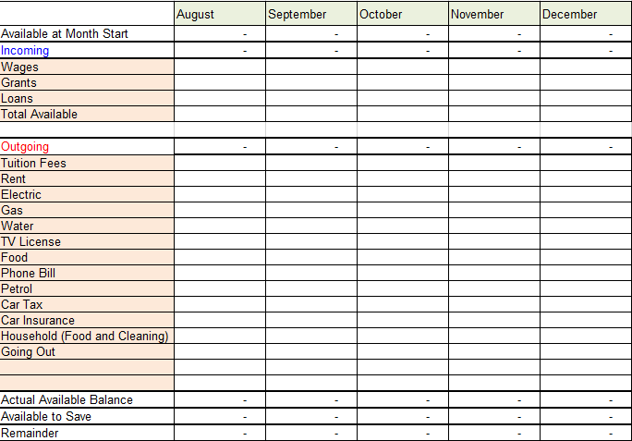

|  |  |
| --- | --- |
| **Restaurants** | Avg. |
| Meal, Inexpensive Restaurant | $12.00 |
| Meal for 2, Mid-range Restaurant, Three-course | $50.00 |
| Combo Meal at McDonalds or Similar | $7.00 |
| Domestic Beer (0.5 litre draught) | $4.00 |
| Imported Beer (0.33 litre bottle) | $5.00 |
| Cappuccino (regular) | $3.78 |
| Coke/Pepsi (0.33 litre bottle) | $1.69 |
| Water (0.33 litre bottle) | $1.36 |
| **Markets** | Avg. |
| Milk (regular), (1 litre) | $0.94 |
| Loaf of Fresh White Bread (500g) | $2.56 |
| Rice (white), (1kg) | $3.52 |
| Eggs (12) | $2.73 |
| Local Cheese (1kg) | $10.50 |
| Chicken Breasts (Boneless, Skinless), (1kg) | $8.70 |
| Apples (1kg) | $4.20 |
| Oranges (1kg) | $4.05 |
| Tomato (1kg) | $4.01 |
| Potato (1kg) | $2.61 |
| Lettuce (1 head) | $1.60 |
| Water (1.5 litre bottle) | $1.76 |
| Bottle of Wine (Mid-Range) | $12.00 |
| Domestic Beer (0.5 litre bottle) | $1.82 |
| Imported Beer (0.33 litre bottle) | $2.41 |
| Pack of Cigarettes (Marlboro) | $6.45 |
| **Transportation** | Avg. |
| One-way Ticket (Local Transport) | $2.25 |
| Monthly Pass (Regular Price) | $70.00 |
| Taxi Start (Normal Tariff) | $3.00 |
| Taxi 1km (Normal Tariff) | $1.55 |
| Taxi 1hour Waiting (Normal Tariff) | $30.00 |
| Gasoline (1 litre) | $0.64 |
| **Utilities (Monthly)** | Avg. |
| Basic (Electricity, Heating, Water, Garbage) for 85m2 Apartment | $148.31 |
| 1 min. of Prepaid Mobile Tariff Local (No Discounts or Plans) | $0.11 |
| Internet (6 Mbps, Unlimited Data, Cable/ADSL) | $49.88 |
| **Sports And Leisure** | Avg. |
| Fitness Club, Monthly Fee for 1 Adult | $37.98 |
| Tennis Court Rent (1 Hour on Weekend) | $17.39 |
| Cinema, International Release, 1 Seat | $11.00 |
| **Clothing And Shoes** | Avg. |
| 1 Pair of Jeans (Levis 501 Or Similar) | $41.80 |
| 1 Summer Dress in a Chain Store (Zara, H&M, ...) | $35.33 |
| 1 Pair of Nike Shoes | $74.86 |
| 1 Pair of Men Leather Shoes | $91.20 |
| **Rent Per Month** | Avg. |
| Apartment (1 bedroom) in City Centre | $1,169.81 |
| Apartment (1 bedroom) Outside of Centre | $881.50 |
| Apartment (3 bedrooms) in City Centre | $1,932.21 |
| Apartment (3 bedrooms) Outside of Centre | $1,460.96 |

Updated February 2016 from: <http://www.numbeo.com/cost-of-living/country_result.jsp?country=United+States>

**Mobile Phones**

Data is very expensive on UK contracts in the US, we recommend you either get a burn phone out there and a local sim or unlock your phone and get a local sim once out there.

# **Accommodation**

|  |  |  |  |
| --- | --- | --- | --- |
| **University** | **Residential Address** | **Approx. Costs** | **Accommodation Contact** |
| Centre College | Centre College  600 West Walnut Street  Danville, Kentucky 40422  USA | $450 per month for 4 month stay. Bills and basic meal plan included.  [Centre Dining Plans](https://centrecollege.sodexomyway.com/dining-plans/index.html) | Stephen Swan  International Student Advisor |
| Oklahoma City University | Oklahoma City University  2501 N. Blackwelder  Oklahoma City, OK 73106 | [OKCU Residence Life](http://www.okcu.edu/campus/residencelife) | Megumi Wilson |
| Stephen .F. Austin State University | 1811 North St.  Nacogdoches, Texas, USA | <https://livetaliesin.com/> | Amanda Hall  Property Manager  Taliesin |

**Oklahoma City University**

Students must live on campus and must live in one of the following; Banning, Draper, Methodist, and Cokesbury.

Banning, Draper, and Methodist require meal plans because none of these have full kitchens. Students who want to live in Cokesbury can purchase a very limited meal plan and have full kitchens in their apartments; Unless you decide to move into a double or quad apartment, you will have to furnish your own pots, pans, plates, etc., for the kitchen.

**Stephen F. Austin University**

The Taliesin apartments are available again – we strongly recommend you use these!

They have advised this site is frequently used;

http://www.banitacreek.com/

Banita Creek offer 6 month, 9 month, and 12 month leases. One bedrooms start at a 12 month lease of $525 a month and go up $25 per shorter lease. Our two bedrooms start at $675 per 12 month lease and will increase $15 per shorter lease (prices approx.).

Other options include;

<http://livecalifornian.com/>

<http://www.liveatlegends.com/>

<http://www.liveatthelofts.com/>

<https://www.apartmentguide.com/apartments/Texas/Stephen-F-Austin-State-University/>

Only use North Park if cannot find anywhere else and preferably if you are with others as the area is not as nice.

# **Important Contacts**



Tiffany Banks

Student Services Officer

Rose Bruford College

Lamorbey Park, Burnt Oak Lane

Sidcup

Kent

DA15 9DF

0208 308 2623

[Tiffany.banks@bruford.ac.uk](mailto:Tiffany.banks@bruford.ac.uk)

Mark Simpson

Rose Bruford College

Lamorbey Park, Burnt Oak Lane

Sidcup

Kent

DA15 9DF

[mark.simpson@bruford.ac.uk](mailto:mark.simpson@bruford.ac.uk)

0208 308 2665

# **Cost Overview**

**\*All costs are estimates\***

* Book any vaccinations that are missing – potential cost depending on number of vaccines missing
* Flights –£600
* SEVIS fee - £140
* MRV fee - £120
* Insurance - £130
* Stocking up on prescriptions if required
* Accommodation deposit
* If your SFE does not cover the amount required you will need to find additional proof from family or from your own bank if you have the funds. **See page 6 for more details.**

**Unless your rent in America is hugely higher than what you pay here you should manage on your finance. If however you want to travel then I would suggest working in the holidays prior to the trip to save some additional funds.**

**If you are funded by SFE then you CAN apply for the Travel Grant! See page 18 for details**