160
ATA5 Study abroad

http://www.practitioners.slc.co.uk/

Table of Contents
Document Requirements 3
Passport 4
Vaccination Record 5
Financial Documents 6
Certificate of Finance 7
RBC Exchange Sheet 8
Application Form 9
Travel/Health Insurance 10
Student Essay 13
F-1 VISA 15
J-1 VISA 21
U.S.A Jargon Buster 27
Travel Grant 28
Budgeting 30
Accommodation 33
Important Contacts 35

Document Requirements

 | Passport | Vaccination Record (Inc. meningitis) | Financial Documents | Certificate of Finance/IS-50 | RBC Exchange Sheet | Application Form | Transcript (supplied by college) | Travel/ Health Insurance | Student Essay
Centre College (Kentucky) |  |  |  | N/A | N/A |  |  |  | N/A
Clemson University (South Carolina) |  |  |  |  | N/A |  |  |  | N/A
Columbia College (Chicago) |  |  |  | N/A | N/A |  |  |  | N/A
SFA (Texas) |  |  |  |  |  |  |  |  | N/A
Syracuse (New York) |  |  |  | N/A | N/A
UArts (Philadelphia) |  |  |  | N/A | N/A |  |  |  | N/A
UNCW (North Carolina) |  |  |  | N/A | N/A | Direct |  |  | N/A

Passport

You can either make a copy yourself or hand to Tiffany Banks to do so. If you decide to make your own copy it needs to be a clear and in colour like the example given below;

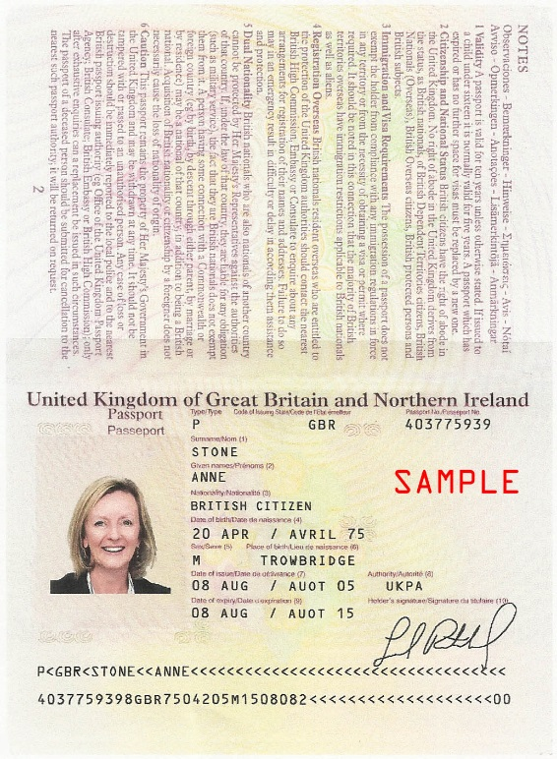

Vaccination Record
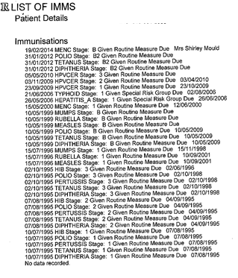

Your vaccination record should look along the lines of this;

You need to make sure you are vaccinated against;
Measles, Mumps & Rubella (MMR)
Tetanus & Diptheria
Bacterial Meningitis (ACW & Y)
Hepatitis B (UNCW Requirement)

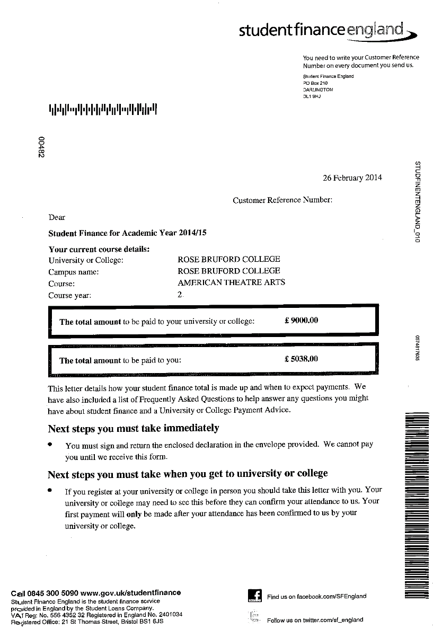

Financial Documents

If you are getting Student Finance for your trip we need the letter that looks like this;

Or an original bank statement from the applicants sponsor(s) verifying funding of approx. $8,500 USD. The funds have to be in your account by the time you make your visa appointment but your confirmation letter needs to be ready before the forms are sent away (April 1st). Make sure you apply for SFE as early as possible! SFE take at least 7-10 days to process applications not taking into account any hiccups that may occur.

The student records team will be sending a spreadsheet off to Student Finance England (SFE) once you are confirmed to go to the U.S.A that lets them know you are a UK student but studying a semester abroad. When you apply for SFE please apply as study abroad.

Certificate of Finance/IS-50 Financial Certification

The form on the left is required if you are going to SFA and only if you are self-funded. The form on the right is for Clemson no matter which funding you get, you must complete this;

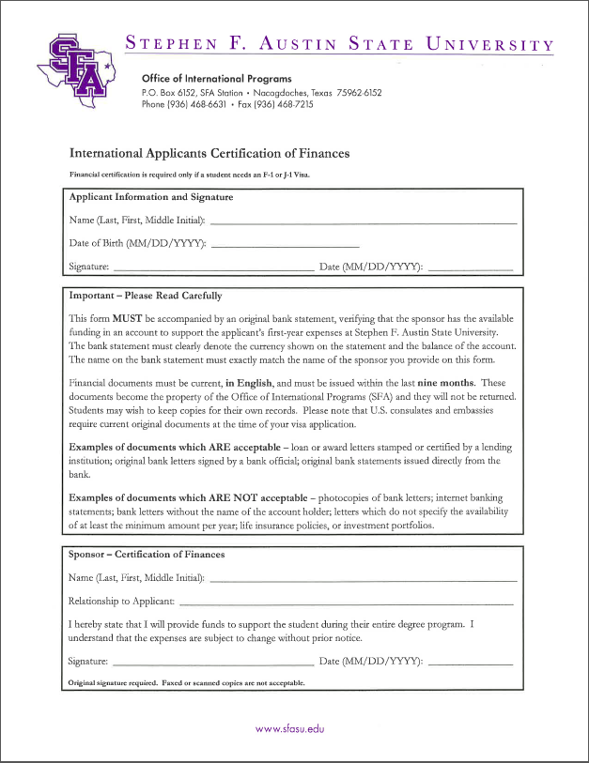
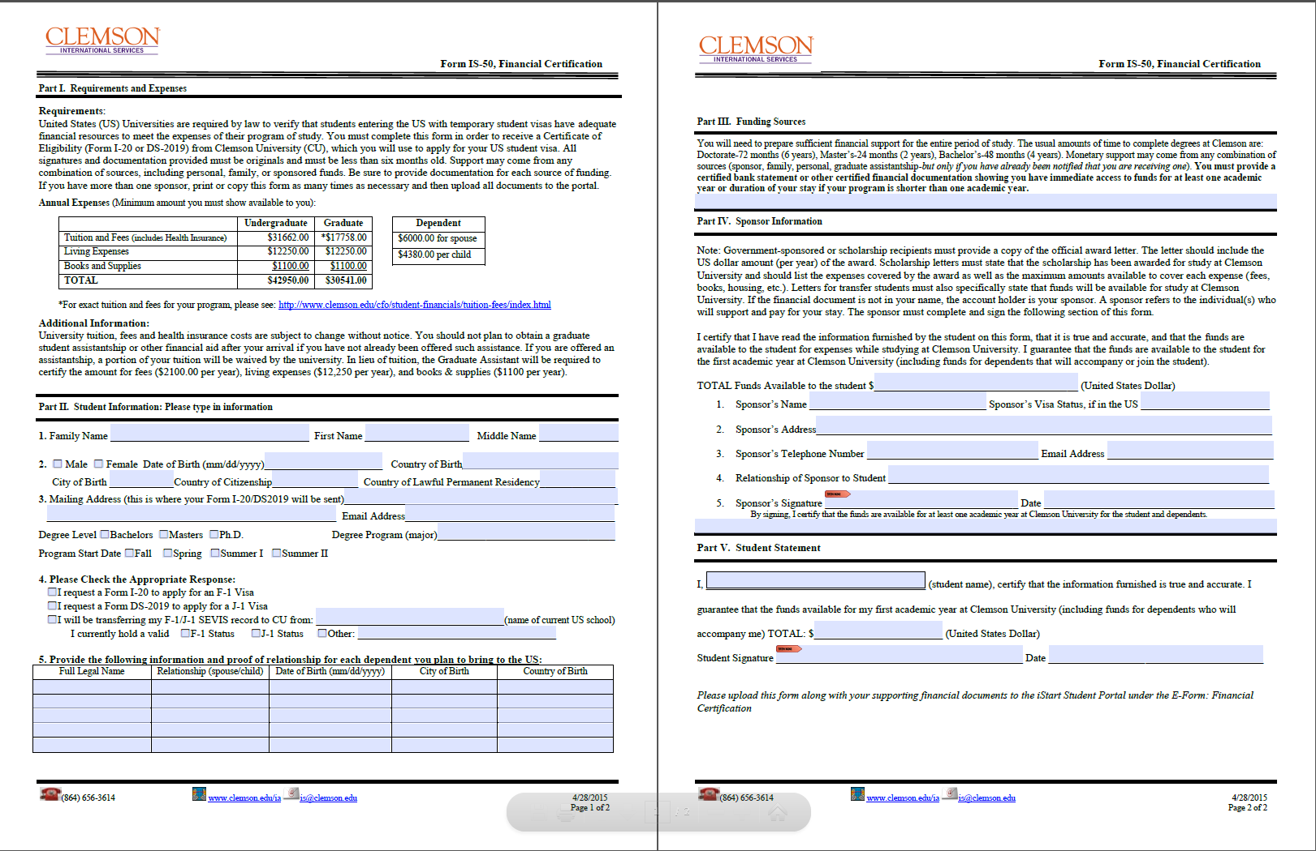

RBC Exchange Sheet

This is only required if you are going to SFA. It looks like this and requires basic information;

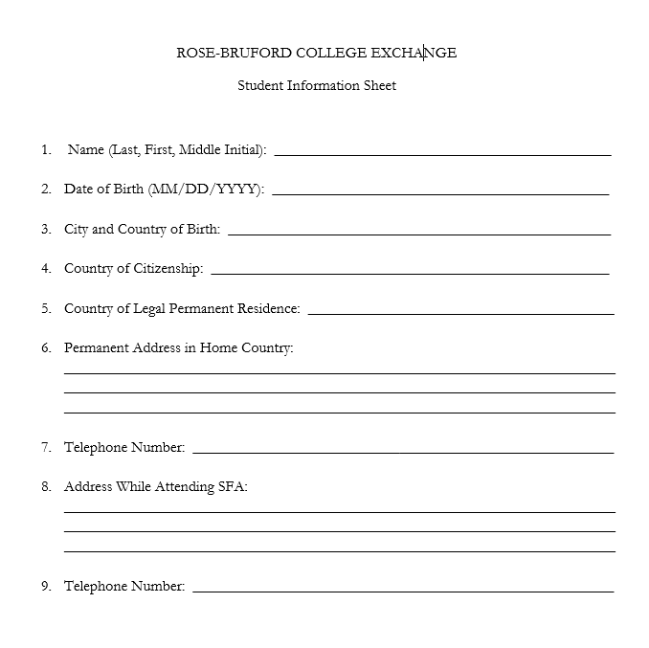

NOTE: Your original hard copy of your student finance letter/bank statement and the certificate of finances MUST be sent to SFA as soon as completed.

Application Form

The application forms are all slightly different as per your destined university, links to these are below;

Centre
Clemson
Columbia
SFA
Syracuse
UArts

SFA NOTE: Student to apply directly to SFA via this link; https://www.applytexas.org/adappc/gen/c_start.WBX and send other docs to Tiffany Banks to forward.

CLEMSON NOTE: Students to apply directly to Clemson via this link; http://terradotta.app.clemson.edu/index.cfm?FuseAction=Programs.ViewProgram&Program_ID=12011.

Travel/Health Insurance

You need to ensure you have insurance to cover you both for the journey and your duration in the U.S.A. If you end up ill you could be paying some pretty hefty bills.

Universities own insurance;

Centre
They offer their own medical insurance which is advised not to purchase while in the UK. Once they arrive in the USA, they will be covered under our plan. It is $106/month and is added into their tuition/room and board payments. In the mean time you can have a look at their website, http://www.lewermark.com/

Clemson
This is AUTOMATIC. All students who participate in a study abroad program will be automatically enrolled in the Clemson University study abroad insurance. This includes all students on Clemson faculty-directed or college coordinated programs, exchange students, students who are studying abroad with external providers and third parties, and direct enrolled students. It applies to students studying abroad for credit and non-credit. This will be automatically assigned to you and then you will be billed for it at a cost of $935 (approx. £600). To opt out you must prove you have sufficient cover as per their stipulations in this link;
http://www.clemson.edu/campus-life/campus-services/redfern/documents/SHP%20Waiver%20Req%20International.pdf

Columbia
Columbia College has implemented a mandatory Student Accident and Sickness Insurance Plan offered by The Lewer Insurance Agency. All international students are automatically enrolled.

We are anticipating the cost to be for the Fall semester to be around $465. This is roughly $114 per month and will be charged directly to your Columbia College Student OASIS account once you register for classes.

Highlights of the plan include:

- Unlimited coverage per condition
- No exclusion for pre-existing conditions
- $0 Deductible per policy year
- Trustmark Group Benefits - CIGNA PPO Network - 100% In Network; 80% Out-of-Network Co-Insurance
- Co-Payments- $15
- Physician, mental health; substance abuse, chiropractic; physical therapy, acupuncture; and occupational therapy visits
- Annual Out of Pocket Maximum - $2,000
- Physical Exam/Wellness Women's Wellness exam - 100% after co-pay
- Prescription Drug Benefit through Express Scripts - reimbursed up to 50% - no annual limit per policy year
- Careington Dental and Vision Benefit - provides a discount network for dental and vision services. (Separate membership cards will be provided)

In addition, the insurance will also include:

- Mental Health Counselling - A toll free number available 24/7 to assist students for any reason, whether school related, family issues, or adjusting to a new environment, the LewerMark Student Assist Program will be available through a network of trained counselors ready to assist.

- Legal Assistance - Students sometimes need advice when it comes to immigration, U.S. laws, liability, or any reason a qualified attorney could provide assistance. The LewerMark Student Assist Program will provide a free 30 minute consultation to students to assist with needs for professional legal advice. Referrals are available for additional fee based services as needed.

- Concierge Service - How many times has a student arrived looking for housing, or possibly finding a local grocer with food from their home country? The LewerMark Student Assist program is available 24/7 to help students find resources for their day to day needs.

For more information on the insurance and the policy details, you can go here: http://students.colum.edu/multicultural/international-student-affairs/international-student-health-insurance.php.

SFA
Our insurance will cost approximately $470 for the fall semester. Students can sign up for the insurance upon their arrival to campus. Alternatively, they can choose their own insurance, but it must conform to the guidelines set forth in the attached document.
Please note: Your own chosen insurance must comply with the above guidelines and cover you from arrival in the US to your last day of studies.

Syracuse
Students studying in the US need to have major medical insurance. Visit the Slutzker Center website for information regarding medical insurance.
http://international.syr.edu/new-students/health-insurance/index.html

If your students’ parents have major medical insurance that will cover them while in the US and meets the requirements that will be sufficient. They will have to produce their insurance card as proof of insurance. If it is not sufficient they will have to purchase more.

UArts
Do not supply insurance

Alternatively here are a couple of other options for you to look at;
http://www.fulbright.org.uk/pre-departure/practical-information/us-healthcare-system

UNCW
Students must upload proof of their insurance to their portal, and their health insurance must meet the U.S. Department of State minimum requirements:
• Medical benefits of at least $100,000 per person per accident or illness
• Repatriation of remains in the amount of $25,000
• Medical Evacuation coverage in the amount of $50,000
• A deductible not to exceed $500 per accident or illness
Regular student health insurance through UNCW – if students wish, they can purchase GeoBlue through UNCW, cost $105 per month (approximate cost). You must request a waiver from GeoBlue via the UNCW portal if you have your own insurance that matches the requirements above.

COE Connections

COE Connections is an travel insurance option. COE does not cover medical so that needs to be separately bought but this is a very good travel insurance option.

COE Connections International are a Long Stay travel insurance specialists in the United Kingdom and can be found at www.coeconnections.co.uk.

We offer a fully automated, IMMEDIATE online Quote and Buy system and our STUDY ABROAD premiums are highly competitive.
Approximate costs;
6 Months EUROPE.....................£91.00
12 Months EUROPE...................£156.00
6 Months WORLDWIDE.............£121.00
12 Months WORLDWIDE...........£178.00

We can cover OVERSEAS students who have already resided in the United Kingdom and studied at a University here for (say) two years and are having their third year as study abroad, before returning back to the UK to complete their studies.

Online Travel Cover

Another insurance option; http://www.onlinetravelcover.com/Default.aspx. The standard long stay cover is approximately £117.99.

Medical Insurance
You can get travel insurance that covers medical, we recommend minimum up to $10m. To compare prices you can use; https://www.moneysupermarket.com/travel-insurance/enquiry/results?qr=36804072. COE Connections includes medical cover.

Non- EU Travel/Medical Insurance
http://www.imgeurope.co.uk/msm/moneysupermarket

PLEASE NOTE
With any of the universities own insurance make sure you have travel and medical insurance to at least cover you up to registration day if you decide to use their personal insurance plans.

Student Essay

This is only required if you are going to Syracuse. It requires the following information;

1.) Descriptive Statements: Please answer the following questions.

- Who or what influenced you to apply to Syracuse University?
- What are your academic and career aspirations?
- What is your most meaningful activity outside the classroom and why?

2.) Personal Essay: In 250-500 words, describe one thing you haven’t yet accomplished in your life that you really want to do. Explain how being at Syracuse University will help you accomplish it.

Please type this up as a word document so it is legible.

F-1 VISA

The F-1 Visa is required if you are going to Centre or Syracuse.

Please read the welcome letter from US COLLEGE carefully when it arrives and (most important of all) your I-20 form, which you need to sign and take with you to your Embassy Appointment. The crucial number is on the right hand corner – above the bar code (e.g. N000123456). You will need this when paying your SEVIS fee ($200) and booking your Embassy appointment.

Form I-20
The main concern of the Embassy (and US Immigration) is that you show that you are a bona fide Visitor to the U.S. with the means to support yourself financially while in the country and have a clear intention to leave the States at the end of your allotted time. The proof of this is contained in your Admission Letter to you and the I-20 form (basically the invite from US State for you to study in the States).

F-1 Visa
You are applying for an F-1 Academic Visa; visit the Embassy website to learn more: https://ceac.state.gov/genniv/

You can watch a video on how to apply for a F1-Visa here!

http://www.youtube.com/watch?v=IhcdWS05Fyw&feature=c4-overview&list=UUFXBhKlGsJ_Ek71dlkFMkYQ

Otherwise please follow these steps:
https://ceac.state.gov/genniv/
Go To STEP 3 – Complete the DS-160 online application

Click on the hyperlink in the form name which brings you to a new page.

You can find the DS-160 form at; https://ceac.state.gov/genniv/

You are now on the web-page you require. You’ll need the following information at hand:
- An electronically correct photograph ready to be uploaded unto the US Embassy system (you can upload a temporary one and then take your preferred version along with on your interview day at the Embassy)
- Passport
- Travel itinerary, if you have already made travel arrangements.
- Dates of your last five visits or trips to the United States, if you have previously travelled to the United States. You may also be asked for your international travel history for the past five years.
- Résumé or Curriculum Vitae - You may be required to provide information about your current and previous education and work history.
- Other Information - Some applicants, depending on the intended purpose of travel, will be asked to provide additional information when completing the DS-160

- During your application each page should save automatically but click save just to be sure!

- As you complete the visa application, save a copy on your hard drive, CD or USB and ‘save’ often;

- Provide accurate and complete information in answer to the questions. You will be given an opportunity to review the information before submitting the form. If you submit a DS-160 that is inaccurate or incomplete, your application will be rejected

- Select a location where you are applying for the visa from, i.e. England, London

- Test Photo – Select this to upload your photo, requirements are listed on this page

- Start New Application. Write down or print off your APPLICATION ID NUMBER and keep it safe because your session may time out and you will need this to get back to your place in the application process

- Select a security question to which you readily remember the answer!

- Personal Information Section 2 - You do NOT have a U.S. Social Security Number or US Taxpayer ID Number. Tick ‘does not apply’ box.

- Travel Information - Select the correct visa category under "Purpose of Travel to the U.S." from the drop down list. You’re an Academic or Language Student (F).

- Travel Information - You will be asked to say who is financing your study? For nearly all of you, I believe this is: ‘other company/an organisation’
  - Student Finance England
  - Tel: 0845 300 50 90
  - Address: PO Box 210
Darlington
DL1 9HJ

- Travel Companions Information - When asked about people you are travelling with put NONE. Although you may be literally on the same flight with your classmates, and sat next to each other – you are effectively travelling alone (no spouse or children / separate ticket and passport).

- Work/Education/Training - When asked the question “Have you attended any educational institutions other than an elementary school”, you should list all educational institutions you have attended since the age of 11

- Work/Education/Training - When asked to fill in as much information as you can about work history - (watch out for American dates!) - do not feel the need to fill in every blank area. One or two holiday jobs will do.

- Security & Background – I would tick no for these as it will halt your application! However if you do have any criminal convictions you MUST tell us as lying will halt your VISA acceptance.

University & Address | Point of Contact | Contacts Information
Centre College  600 West Walnut Street  Danville, Kentucky 40422  USA | Tim Culhan  Registrar | Number: 859 238 5360  Email: Tim.culhan@centre.edu  Add: Centre College  600 West Walnut Street  Danville, Kentucky 40422  USA
Syracuse University  310 Walnut Place  Syracuse, New York 13244-2380  USA | Debra Goddard Admissions Counsellor | Number: 315 443 2528  Email: dsgoddar@syr.edu  Add: Syracuse University  310 Walnut Place  Syracuse, New York 13244-2380  USA

F-1 Other Documentation
The decision to approve or deny the application will be based on the interview and information provided orally. However, the consular officer may ask the applicant to provide documentary evidence of the following:
- Funds sufficient to cover all expenses including tuition while in the United States. Such evidence may include detailed bank statements of your or your parent's accounts showing that adequate funds are available for transfer, evidence of scholarships and/or combination of finances which will meet the estimated total expenses, including tuition, of your proposed stay in the United States: a combination of the letters you have from Student Finance England (or your parents’ bank), Columbia and Rose Bruford should be sufficient.

- Evidence of a residence in the UK to which you intend to return at the end of the stay in the United States. This is generally established by evidence of family, professional, property, employment or other ties and commitments to some country other than the United States sufficient to cause you to return here at the conclusion of your stay: this is the pdf letter written from Steve on headed notepaper from Rose Bruford, which will constitute part of your DOCUMENT OF INTENT TO RETURN TO YOUR COUNTRY OF RESIDENCE.

- Proof of insurance is not required when applying for a visa, but you may well be asked at Immigration, so make sure you are covered before you fly out and answer in the affirmative if or when they ask if you’re covered.

- Your passport / documentation will be returned by the Embassy by Post. On the day of the visa interview you will be required to purchase an envelope for the return of your passport once visa processing has been completed. The fee for the courier service starts at £14:80; payable by credit or debit card or in cash. Remember, you have to be at home to sign for the Special Delivery when it arrives back.

- VISA appointments at the Embassy must happen a minimum of 10 days before you fly out.
Note: Once the U.S Universities have processed your documentation we send over they will process the DS-160 which you use to apply for your Visa

CHECKLIST FOR U.S. EMBASSY

- Your (up to date) passport
- Your signed I-20 form from US College
- Your completed and signed DS-160 forms
- Your letter of acceptance from US College
- The supporting Documentation of Intent to Return letter from me
- Parents’ letter stating your permanent residence is in the UK
- A document from your Student Finance England or your parents’ bank
- Evidence of your own personal bank account (if self-funded)
- SEVIS fee receipt (confirmation of payment)
- MRV fee receipt (sent to you by the Embassy)

The link to pay your MRV fee is within your completed online visa paperwork and to pay your SEVIS fee go here; https://www.fmjfee.com/

Please let us know when you have arranged your Embassy appointment.

US EMBASSY Operator Assisted Visa Information
Call (0)20 3608 6998 (this is a London number. It does not require any other prefix or dialing code.) Service available Monday through Friday, 7.00 a.m. until 7.00 p.m.

Or https://uk.usembassy.gov/visas/visa-information-services/contact-us-immigrant-visas/u-s-embassy-london-visa-unit-contact-form/

J-1 VISA

The J-1 Visa is required if you are going to UArts, Clemson, SFA, Columbia or UNCW.

Please read the welcome letter from US COLLEGE carefully when it arrives and (most important of all) your DS-2019 form, which you need to sign and take with you to your Embassy Appointment. The crucial number is on the right hand corner – above the bar code (e.g. N000123456). You will need this when paying your SEVIS fee ($180) and booking your Embassy appointment.

Form DS-2019
The main concern of the Embassy (and US Immigration) is that you show that you are a bona fide Visitor to the U.S. with the means to support yourself financially while in the country and have a clear intention to leave the States at the end of your allotted time. The proof of this is contained in your Admission Letter to you and the DS-2019 form (basically the invite from US State for you to take part in an academic exchange).

J-1 Visa
You are applying for a J-1 Exchange Visa. Visit the Embassy website to learn more: https://ceac.state.gov/genniv/

You can watch a video on how to apply for a J1-Visa here!
http://www.youtube.com/watch?v=IhcdWS05Fyw&feature=c4-overview&list=UUFXBhKlGsJ_Ek71dlkFMkYQ

Otherwise please follow these steps:
https://ceac.state.gov/genniv/
Go To STEP 3 – Complete the DS-160 online application

Click on the hyperlink in the form name which brings you to a new page.

You can find the DS-160 form at; https://ceac.state.gov/genniv/

You are now on the web-page you require. You’ll need the following information at hand:
- An electronically correct photograph ready to be uploaded unto the US Embassy system (you can upload a temporary one and then take your preferred version along with on your interview day at the Embassy)
- Passport
- Travel itinerary, if you have already made travel arrangements.
- Dates of your last five visits or trips to the United States, if you have previously travelled to the United States. You may also be asked for your international travel history for the past five years.
- Résumé or Curriculum Vitae - You may be required to provide information about your current and previous education and work history.
- Other Information - Some applicants, depending on the intended purpose of travel, will be asked to provide additional information when completing the DS-160

- During your application each page should save automatically but click save just to be sure!

- As you complete the visa application, save a copy on your hard drive, CD or USB and ‘save’ often;

- Provide accurate and complete information in answer to the questions. You will be given an opportunity to review the information before submitting the form. If you submit a DS-160 that is inaccurate or incomplete, your application will be rejected

- Select a location where you are applying for the visa from, i.e. England, London

- Test Photo – Select this to upload your photo, requirements are listed on this page

- Start New Application. Write down or print off your APPLICATION ID NUMBER and keep it safe because your session may time out and you will need this to get back to your place in the application process

- Select a security question to which you readily remember the answer!

- Personal Information Section 2 - You do NOT have a U.S. Social Security Number or US Taxpayer ID Number. Tick ‘does not apply’ box.

- Travel Information - Select the correct visa category under "Purpose of Travel to the U.S." from the drop down list. You’re an Exchange Visitor (J).

- Travel Information - You will be asked to say who is financing your study? For nearly all of you, I believe this is: ‘other company/an organisation’
  - Student Finance England
  - Tel: 0845 300 50 90
  - Address: PO Box 210
Darlington
DL1 9HJ
- Travel Companions Information - When asked about people you are travelling with put NONE. Although you may be literally on the same flight with your classmates, and sat next to each other – you are effectively travelling alone (no spouse or children / separate ticket and passport).

- Work/Education/Training - When asked the question “Have you attended any educational institutions other than an elementary school”, you should list all educational institutions you have attended since the age of 11

- Work/Education/Training - When asked to fill in as much information as you can about work history - (watch out for American dates!) - do not feel the need to fill in every blank area. One or two holiday jobs will do.

- Security & Background – I would tick no for these as it will halt your application! However if you do have any criminal convictions you MUST tell us as lying will halt your VISA acceptance.

Important Contact Information:
University & Address | Point of Contact | Contacts Information
Columbia College  600 s. Michigan Avenue  Chicago, Illinois 60605  USA | Alex Riepl Broz | Number: 312 369 7983  Email: arieple@colum.edu  Add: Columbia College  600 s. Michigan Avenue  Chicago, Illinois 60605
Clemson University  E-301 Martin Hall  Box 345714  Clemson, SC 29634 | Mandy Prorok  Associate Director for International Undergraduate Programs & Exchanges | Number: (864) 656-3614  Email: mprorok@clemson.edu  Add: Clemson University  E-301 Martin Hall  Box 345714  Clemson, SC 29634
Stephen .F. Austin State University  SFA Station  Nacogdoches  Texas 75962  USA | Heather Catton  Director  Office of International Programs | Number: 936 468 3927  Email: international@sfasu.edu  Add: Stephen .F. Austin State University  SFA Station  Nacogdoches  Texas 75962
University of the Arts  320 South Broad Street  Philadelphia  PA 19102  USA | Study Abroad Department | Number: 215 717 6389  Email: studyabroad@uarts.edu  Add: University of the Arts  320 South Broad Street  Philadelphia  PA 19102
University of North Carolina Wilmington  601 South College Rd  Wilmington, NC 28403-5965  USA | Ashley Krutz  Education Abroad Advisor | Number: 910.962.3685  Email: krutza@uncw.edu  Add: 601 South College Rd  Wilmington, NC 28403-5965  USA

J-1 Other Documentation

The decision to approve or deny the application will be based on the interview and information provided orally. However, the consular officer may ask the applicant to provide documentary evidence of the following:

- Funds sufficient to cover all expenses including tuition while in the United States. Such evidence may include detailed bank statements of your or your parent's accounts showing that adequate funds are available for transfer, evidence of scholarships and/or combination of finances which will meet the estimated total expenses, including tuition, of your proposed stay in the United States: a combination of the letters you have from Student Finance England (or your parents’ bank), Columbia and Rose Bruford should be sufficient.

- Evidence of a residence in the UK to which you intend to return at the end of the stay in the United States. This is generally established by evidence of family, professional, property, employment or other ties and commitments to some country other than the United States sufficient to cause you to return here at the conclusion of your stay.

- Detailed information concerning your academic qualifications. Such evidence may include complete transcripts of grade (marks) and test records of the last four years of school and evidence of TOEFL (Test of English as a Foreign Language) scores. You won’t need this. It’s self-evident from the aforementioned letters.

- Proof of insurance is not required when applying for a visa, but you may well be asked at Immigration, so make sure you are covered before you fly out and answer in the affirmative if or when they ask if you’re covered.

- Your passport / documentation will be returned by the Embassy by Post. On the day of the visa interview you will be required to purchase an envelope for the return of your passport once visa processing has been completed. The fee for the courier service starts at £14:80; payable by credit or debit card or in cash. Remember, you have to be at home to sign for the Special Delivery when it arrives back.

- VISA appointments at the Embassy must happen a minimum of 10 days before you fly out.
Note: Once the U.S Universities have processed your documentation we send over they will process the DS-2019 which you use to apply for your Visa

Clemson will charge you around £45 to send your visa documents, the College will either pay you back in the following semester or you pay less for theatre tickets. For more information ask Steve Dykes.

CHECKLIST FOR U.S. EMBASSY

- Your (up to date) passport
- Your signed DS-2019 form from US College
- Your completed and signed DS-160 forms
- Your letter of acceptance from US College
- The supporting Documentation of Intent to Return letter from me
- Parents’ letter stating your permanent residence is in the UK
- A document from your Student Finance England or your parents’ bank
- Evidence of your own personal bank account (if self-funded)
- SEVIS fee receipt (confirmation of payment)
- MRV fee receipt (sent to you by the Embassy)

The link to pay your MRV fee is within your completed online visa paperwork and to pay your SEVIS fee go here; https://www.fmjfee.com/

Please let us know when you have arranged your Embassy appointment.

US EMBASSY Operator Assisted Visa Information
Call (0)20 3608 6998 (this is a London number. It does not require any other prefix or dialing code.) Service available Monday through Friday, 7.00 a.m. until 7.00 p.m.
Or https://uk.usembassy.gov/visas/visa-information-services/contact-us-immigrant-visas/u-s-embassy-london-visa-unit-contact-form/

U.S.A Jargon Buster
American | British
Doctor | G.P (General Practitioner)
Clinic | Doctor's Surgery
Surgery | Operation
Operating Room (O.R.) | Theatre
Emergency Room (E.R.) | Accident and Emergency (A&E)
Tylenol/Acetaminophen | Paracetamol
Advil | Nurofen
Excedrin | Anadin Extra  (Paracetamol/Aspirin/Caffeine)
Band-Aids | Plasters
National Health What?... | National Health Service (NHS)

Travel Grant

The student records team send SFE a list of all students going to the U.S.A and how long for so you should in time receive the travel grant application if you are applicable for it. Our student records team can send this list anytime until the end of June. If you don’t receive a form you can ring SFE directly and request one.

Travel Grant
A Travel Grant is available to full-time students studying abroad as part of their course.

How do students qualify?
Students can apply for a Travel Grant if they’re studying a full-time higher education course and getting student finance that depends on their household income, for example Maintenance Loan or Maintenance Grant. Students must also be:
- attending an overseas institution for at least 50% of any academic term. This period of study can be compulsory or optional. If they’re on a work placement abroad they won’t be eligible for a Travel Grant

How much can students get?
The amount of Travel Grant students can get depends on their household income and covers reasonable travel expenses during an academic year.

The first £303 of travel costs are disregarded so they can get their travels costs less the first £303. The method and class of travel, along with all other expenditure costs, must be reasonable.

Students must purchase the most cost effective tickets using the most economical and practical form of transport. For example, train instead of flying and standard-class instead of first-class tickets. If eligible, students can claim for:
- Up to three return journeys between the UK and the overseas institution during a full academic year abroad
- Any necessary travel costs
- Mandatory Medical Insurance, Visas and Medical Expenses for the purpose of studying abroad

What evidence do students have to send?
Evidence must be provided to support claims for travel expenses. They’ll only get the full amount of Travel Grant if they send us all the evidence we ask for. Please provide photocopies as proof of the payment made. Evidence must be proof of payment, not just an itinerary or quote. For example, this could be an e-receipt for payment of flights.

How do students get paid?
Students can apply for a Travel Grant at any time during the academic year. Funding will be paid on an ad hoc basis so they won’t have to wait until their next instalment of student finance to get the Travel Grant. There’s no limit to how many travel grant forms students can submit.

Columbia College – Travel Note
Columbia have a compulsory travel pass for your time there. This is $130 and covers all Chicago public transportation (bus and rail) for the entire semester!

Budgeting

Below are the average costs for living/staying in the U.S.A;

Restaurants | Avg.
Meal, Inexpensive Restaurant | $12.00
Meal for 2, Mid-range Restaurant, Three-course | $50.00
Combo Meal at McDonalds or Similar | $7.00
Domestic Beer (0.5 litre draught) | $4.00
Imported Beer (0.33 litre bottle) | $5.00
Cappuccino (regular) | $3.78
Coke/Pepsi (0.33 litre bottle) | $1.69
Water (0.33 litre bottle) | $1.36
Markets | Avg.
Milk (regular), (1 litre) | $0.94
Loaf of Fresh White Bread (500g) | $2.56
Rice (white), (1kg) | $3.52
Eggs (12) | $2.73
Local Cheese (1kg) | $10.50
Chicken Breasts (Boneless, Skinless), (1kg) | $8.70
Apples (1kg) | $4.20
Oranges (1kg) | $4.05
Tomato (1kg) | $4.01
Potato (1kg) | $2.61
Lettuce (1 head) | $1.60
Water (1.5 litre bottle) | $1.76
Bottle of Wine (Mid-Range) | $12.00
Domestic Beer (0.5 litre bottle) | $1.82
Imported Beer (0.33 litre bottle) | $2.41
Pack of Cigarettes (Marlboro) | $6.45
Transportation | Avg.
One-way Ticket (Local Transport) | $2.25
Monthly Pass (Regular Price) | $70.00
Taxi Start (Normal Tariff) | $3.00
Taxi 1km (Normal Tariff) | $1.55
Taxi 1hour Waiting (Normal Tariff) | $30.00
Gasoline (1 litre) | $0.64
Utilities (Monthly) | Avg.
Basic (Electricity, Heating, Water, Garbage) for 85m2 Apartment | $148.31
1 min. of Prepaid Mobile Tariff Local (No Discounts or Plans) | $0.11
Internet (6 Mbps, Unlimited Data, Cable/ADSL) | $49.88
Sports And Leisure | Avg.
Fitness Club, Monthly Fee for 1 Adult | $37.98
Tennis Court Rent (1 Hour on Weekend) | $17.39
Cinema, International Release, 1 Seat | $11.00
Clothing And Shoes | Avg.
1 Pair of Jeans (Levis 501 Or Similar) | $41.80
1 Summer Dress in a Chain Store (Zara, H&M, ...) | $35.33
1 Pair of Nike Shoes | $74.86
1 Pair of Men Leather Shoes | $91.20
Rent Per Month | Avg.
Apartment (1 bedroom) in City Centre | $1,169.81
Apartment (1 bedroom) Outside of Centre | $881.50
Apartment (3 bedrooms) in City Centre | $1,932.21
Apartment (3 bedrooms) Outside of Centre | $1,460.96
Updated February 2016 from: http://www.numbeo.com/cost-of-living/country_result.jsp?country=United+States

You can also try this budget planner to work out how much you have left after bills, insurance etc.

At a glance it looks like this!
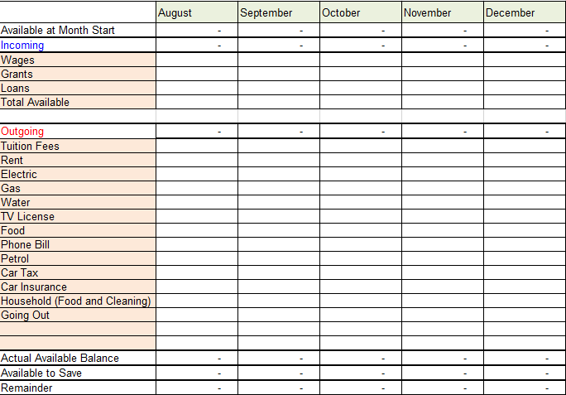

Mobile Phones

Data is very expensive on UK contracts in the US, we recommend you either get a burn phone out there and a local sim or unlock your phone and get a local sim once out there.

Accommodation
The following universities have their own residences;

University | Residential Address | Approx. Costs | Accommodation Contact
Centre College | Centre College  600 West Walnut Street  Danville, Kentucky 40422  USA | $450 per month for 4 month stay. Bills and basic meal plan included.  Centre Dining Plans | Stephen Swan  International Student Advisor
Clemson University | Clemson University  Manning Hall  Clemson,  SC 29631 | Clemson On-Campus Housing  Clemson On-Campus Room Rates | Mandy Prorok  Associate Director for International Undergraduate Programs and Exchange
Columbia College | Columbia College  731 s. Plymouth Court  Chicago, Illinois 60605 | Residence Hall Rates 2016-17 | Gigi Posejpal  Office of International Student Affairs
Stephen .F. Austin State University | 1811 North St.  Nacogdoches, Texas, USA | N/A | Not available for students – use as temp address on Visa application.
Syracuse University | Syracuse University  900 S Crouse Avenue  Syracuse, NY 13210  USA | North Campus:  Suite ($4,135)  South Campus:  2 bed apart. ($4,745)  3 bed apart. ($4,380) | Deb Goddard  Admissions Counsellor
University of the Arts | 1499 Pine Street  Furness Hall  Philadelphia  PA 19102 | UArts Residence Halls  UArts Residence Room Rates 2015-16 | Study Abroad Department
University of North Carolina Wilmington | 601 South College Rd  Wilmington, NC 28403-5965  USA | On Campus Housing  With your offer of admission, you have earned a "Teal Ticket" to guide you step-by-step through the enrolment process.  On Campus Housing Rates | Amy Mabery  Exchange Visitor Specialist, International Student & Scholar Services

Please Note: The prices above are approximate and may change

Alternatively you can also check;

Clemson University
It is advised you utilise campus housing as off-campus can be difficult to obtain alongside most properties are a year lease.
https://clemsonoffcampus.com/

Columbia College
http://students.colum.edu/residence-life/Housing_Options/index.php

Stephen F. Austin University
The Taliesin apartments are no longer available but they have advised this site is frequently used;
http://www.banitacreek.com/

Banita Creek offer 6 month, 9 month, and 12 month leases. One bedrooms start at a 12 month lease of $525 a month and go up $25 per shorter lease. Our two bedrooms start at $675 per 12 month lease and will increase $15 per shorter lease (prices approx.).

Other options include;
http://livecalifornian.com/
http://www.liveatlegends.com/
http://www.liveatthelofts.com/

Syracuse

UArts
offcampushousing.uarts.edu which is where they direct all landlords to post and it also has a roommate section where students can find other students to connect with.
Or
On Facebook, if you search “UArts Off-Campus housing” you will find a lot of students posting about sublets.

University of North Carolina Wilmington
http://uncw.edu/PERCH/ is the site provided by UNCW for off-campus housing.

Recommended locations
There are multiple student friendly apartments on Racine Dr. and Randall Pkwy (between College Rd and S Kerr Ave), see Google maps showing the walking distance to an apartment on Randall Pkwy. These apartments are within walking/biking distance from campus. Anything further away from campus is not recommended since the students will not have a car.

Contacting local apartment companies
The students will probably need to call the rental companies to ask questions or clarify details regarding their situation. I recommend they buy internet phone credits (such as Skype Out credits) so they can make cheap calls to the U.S. using their computers.

Apartments on Randall Pkwy and Racine Dr. include:
• Carolina Cove Apartments
• Mill Creek Apartments
• The Lofts
• Campus Evolution Villages
• Cypress Point Apartments
• Clear Run Apartments
• Hawthorne Lofts South

What to look for:
• Furnished bedroom in a larger apartment
• Utilities included in monthly rent (the student won’t be here long enough to sign a contract with the utility companies)
• Lease can end in December (he doesn’t want to commit to paying for 12 months if he only needs 4.5 months)

Important Contacts

Tiffany Banks
Student Services Officer
Rose Bruford College
Lamorbey Park, Burnt Oak Lane
Sidcup
Kent
DA15 9DF
0208 308 2623
Tiffany.banks@bruford.ac.uk

Steve Dykes
ATA Programme Director
11 Elliscombe Road
London
SE7 7PF
0208 853 1664
steve.dykes@bruford.ac.uk

Tony James
ATA Tutor
127 Riverside Mansions
Milk Yard
Garnet Street
London
E1 3SZ
0207 265 0469
tony.james@bruford.ac.uk

